Annexure 4

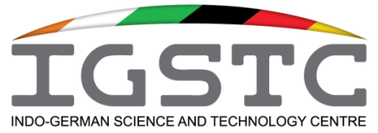

INDO-GERMAN SCIENCE & TECHNOLOGY CENTRE
Plot No. 102, Institutional Area, Sector - 44, Gurgaon - 122003, India

BILATERAL WORKSHOP / CONFERENCE / ROUND TABLE / BRAINSTORMING MEETING REPORT (Use Annexures if necessary)
(Report to be submitted electronically to Director, IGSTC (director.igstc@igstc.org) and Manager (Accts & Admin) (accounts.igstc@igstc.org) within 8 weeks of the completion of the event)

1. Title of the Workshop / Conference:

2. IGSTC Sanction Letter Number:

3. Name, affiliation and e-mail addresses of the Principal Coordinators:
(i) Indian Coordinator:

(ii) German Coordinator:

4. Venue and dates of the event:

5. Number of Indian and German participants:

6. Lead resource persons and speakers from India and Germany (please list them in the following format):

INDIA
S. No. | Title | Name | Affiliation | E-mail

GERMANY
S. No. | Title | Name | Affiliation | E-mail

7. Technical agenda of the event:

8. Academic highlights of the event:

(i) Highlights of scientific and technical presentations / deliberations:

(ii) New developments presented at the event:

(iii) Major recommendations of the event:

9. Specific outcomes (in terms of Indo-German S&T engagement) and future plans emerging out of the event: (Not more than 400 words)

10. Please include at least two or more representative photographs ( provide the soft copies as separate JPEG attachments).

